

**CEO Report – August 2021**

**Phibion Group Holdings Pty Ltd**

**ACN: 648 271 489**

**Report Date: XX September 2021**

**Prepared for: Phibion Board**

|  |  |  |  |  |
| --- | --- | --- | --- | --- |
| **Version #** | **Version** | **Details** | **Issued by:** | **Date** |
| **1.0** | **Final** | **Issued to Board** | **Jacques Janse** | **15/09/21** |
|  |  |  |  |  |
|  |  |  |  |  |

**File: 20210915 - Phibion - CEO Report - August 2021.docx**

**CEO Report**

**Phibion Group Holdings Pty Ltd**

TABLE OF CONTENTS

1.0 Safety 3

2.0 Highlights 3

3.0 Challenges 4

4.0 Finances 4

5.0 Sales 6

6.0 Marketing 7

7.0 Manufacturing 8

8.0 Research & Development 10

9.0 Operations 12

10.0 People 16

11.0 Strategic Plan - Actions 18

# Safety

All sites except Ravensthorpe (contract ended first week of August) attended monthly safety meetings. 100% compliance.

|  |  |  |  |  |  |  |  |
| --- | --- | --- | --- | --- | --- | --- | --- |
|  | Total Shift Hours | Total AMC Hours | LTI’s | DI’s | MTC | Near Miss | Incidents |
| Target | 3,319 | 2,397 | 0 | 0 | 0 | 0 | 0 |
| Actual | 3,307 | 1,931 | 0 | 0 | 0 | 0 | 2 |

**Incidents:**

**South32 – Worsley Alumina**

* 2nd August 2021 - Amphirol machine A6 while working in North Valley Cell 2 drove into a hole created by previous excavations and the area was not demarcated, machine inclined to one side and operator stopped and reversed immediately, incident reported in South32 system, no medical treatment or lost time.
* 11th August 2021 – MM23 front ladder bent, chain dislodged from carbine, no medical treatment or lost time.

# Highlights

* MM18 (Andoom) received new scrolls. Existing scrolls 5,932 hrs operational life.
* MMX returned to the workshop to change scrolls/electrical upgrade.
* New Maintenance Engineer (Uyen Tran) joined Phibion.
* New Workshop Assembler (Hemant Machhi) joined Phibion.
* Contract re-negotiations continue with Lynas Mt Weld
* MM25 arrived in Belem (Brazil) awaiting clearance from Brazil authorities, expected mid-September
* Presented to MRN Shareholder Technical Committee – explained process and progress – well received.
* Phibion Chile employed first MudMaster® Operators, onboarded 2nd August, high altitude medical completed, inducted into Anglo American - Las Tortolas system, commenced theoretical training.
* Tim Varcoe (Phibion MRN Superintendent) left Trombetas Brazil, in transfer now to Santiago to commission for Anglo American – Las Tortolas (Chile) first MudMaster® Machine MM27
* First off-site fabrication of MudMaster sub-assemblies has commenced. Feedback to date from sub-assembly suppliers is positive.

# Challenges

* COVID-19 lockdown imposed around the country:
  + Transit limitations on flight arrangements May impact on FIFO crews to Weipa. Sustainable management plan in place to manage (aligned with Rio Tinto).
  + Border closures to WA (and returning to Queensland) limiting access if required
* Jamalco refinery power station fire that affected operations, refinery shutdown and expected to come back online sometime in November, AMC operations continue. This is a significant event and we expect a commercial impact. We have yet to receive formal notification/communication of the event from Jamalco. We are considering options to manage under a range of scenarios.
* Issue orders for support jigs/fabrication stands to support offsite module fabrication
* Final resolution on proposed machine for autonomous research – either MMX or Ravensthorpe machine (if acquired).
* Moving target on access to Chile – visas. Working closely with Austrade to secure arrangements
* Brazilian Operation Supervisor to take charge of MRN operations, in close contact with Brisbane office for support.
* Issuing orders for replacement scrolls to Brazil fabricator – need to carefully consider QA process
* Reviewing need/process to provide a service trailer and crib hut (reduce travel time losses) for Worsley Alumina consideration.
* Chile VAT exemption application underway yet to be confirmed

# Finances

* FY2022 Phibion Budget and MudMaster® fabrication schedule confirmed
* Potential for grant application under evaluation – no progress as yet

**Key P&L results:**

**Notable items**

**Key Balance Sheet results:**

**Revenue Forecast**

# Sales

The preliminary budget for FY22 new sales has been proposed and is reflected below.

TBA

There will be 5 machines delivered in the period July 21 through to December 2021 and then the balance of 10 machines will be delivered between January 2022 and June 2022.

There were no sales in the month of June, however numerous mature opportunities were targeted to progress through the sales stages and gates. These included Collahuasi, Cerro Verde, Escondida and Ellatzite.

## Sales Activities

### Anglo American

Los Tortolas – 1 MudMaster dispatched at the end of June 2021.

Los Tortolas – Discussions around another machine.

Collahuasi – Two meetings held, and the opportunity is progressing well.

### BHP

Escondida – Informed that the Phibion solution has passed technical approval as well as progressing through the procurement process. A contract should be issued in the next two weeks for review. This is a trial for four (4) machines.

### Ellatzite MED

Ellatzite – proposal has been sent and customer is requesting weight and dimension details as well as HS codes. All indications are that the sale will go through this month. This is an outright sale of one additional machine.

### FMI

Cerro Verde – customer is satisfied that the solution is practical and is their most desirable solution. Procurement will need to assess the opportunity. This is a trial for 2 machines.

### FMQ

Ravensthorpe – A trial machine is performing well and further discussions around a permanent contract will commence when a scan has been conducted and the results can be quantified.

#### Rio Tinto

Andoom – Jacques Janse and Ross Hafner will attend site in mid-July to receive training and to discuss the potential for an additional machine on site. The sales pipeline will be updated at the conclusion of this meeting.

# Marketing

The marketing activity has predominantly revolved around LinkedIn posts during the month, but the following items will commence during the coming month:

1. Marketing calendar
2. Proposal template
3. Sales presentation
4. Technical presentation
5. Case studies will be identified and produced
6. Customer testimonials will be agreed upon and planning commenced
7. Additional sales assets will be designed to support the sales teams
8. Any translations will be identified and concluded
9. Conferences and Trade Shows will be identified and shortlisted

There have been substantial assets developed by the business previously and they will form the basis of future collateral.

## LINKEDIN VIEWS

## LINKEDIN –POSTS

# Manufacturing

## Machines Delivered

**Nil**.

## Machines under Construction

**FY22 MudMaster Construction Plan**

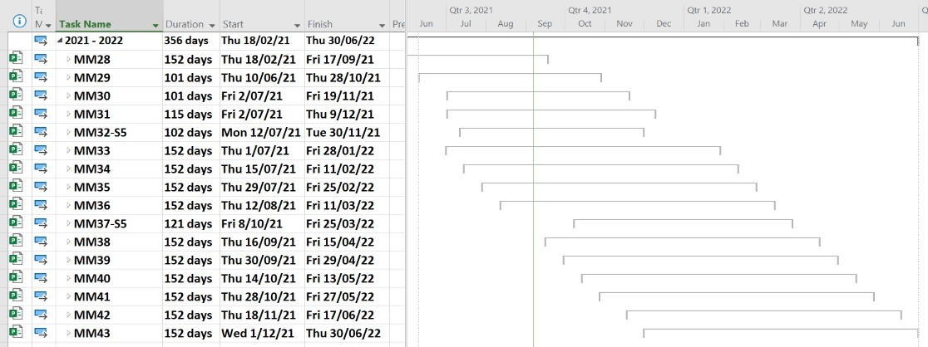

**MM28** Hydraulic commissioning has been completed, handrails and stickers installed. This machine is being used as a teaching aid for our new employee Hemant Machhi, who will be responsible for machine assembly, this has slowed completion of the machine slightly, however we are expecting to have this completed by 17th September 2021 due largely to a delay in obtaining the fold up seat for the cabin.

**MM29 – MM32** The engine module for MM29 is being assembled at our Hydraulic contractor’s workshop. The operator’s cabin for MM29 is at the upholsterers and will be sent directly to our Electrical contractor for assembling at their workshop. This marks the start of a new procedure whereby a significant portion of the assembly will be off-site. Ultimately, we will also be conducting a portion of the commissioning work at these locations. Receiving completed sub-assemblies will help alleviate some congestion expected in our workshop once production starts to ramp up.

## Potential issues:

We continue to work with Energy Power Systems Australia to limit our exposure to CAT engine supply issues. We have 3 existing “fan to flywheel” configuration engines set aside to be built up to our spec which partially fills the gap to March. We continue to apply pressure to fully cover our needs.

Our contract for the MudMaster® Series V machine (MM32) into Bulgaria has hit a hurdle due to their requirement for a Tier 4 stage 5 exhaust compliant engine (our current engine supply are all Tier 3). The Bulgarians are seeking an exemption (from the Government), but we won’t have an answer to this for a month and may be a refusal to accept anything less anyway. We have been working with Energy Power Systems to source a suitable replacement engine (and have been frantically re-designing components to suit), however there are no stocks of these engines in Australia (42 weeks ex factory), and we are trying to source a compliant engine directly from Europe.

# Research & Development

## MudMeter (Dielectric Sensor)

### Background

This project is a coordinated effort between Phibion and University of Queensland. The main innovation of this project is the quantification of the density of mine waste based on non-invasive measurements of the dielectric permittivity.

Phase 1 – Proof of Concept (Antenna / VNA in controlled environment)

Phase 2 – Develop Dielectric Sensor (MudMeter) as an operational prototype

The investment required for this phase is cash contribution:

$53,000 AUD - over 12 months (2x $26,500 AUD per 6 months)

Innovations Connection Grant submitted and approved – 28/07/2021

Phase 2 Work Packages (WP1 – WP4):

**WP1**: Merging of antenna and VNA, and assembly of the system on the MudMaster® (Brisbane)

* VNA real-time logging has been established.
* UQ members to visit Phibion premises 7th September 2021.
* Next step is to mount VNA and Antenna on MudMaster.

**WP2**: On-site calibration procedure for antenna and material (Brisbane

**WP3**: Library of calibration functions for tailings materials (Brisbane)

**WP4**: Field test with data analysis

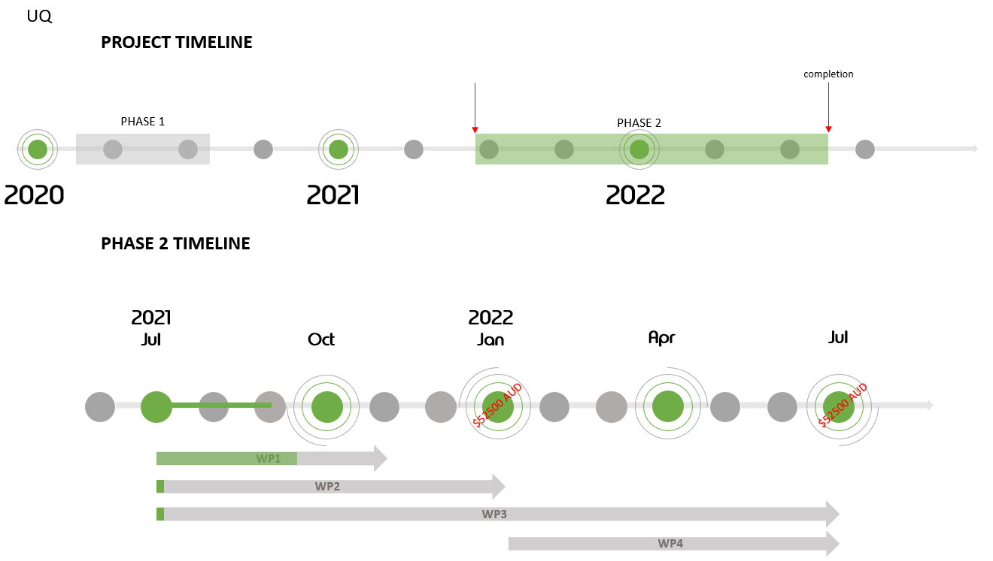

## MMBot (MudMaster® Automation)

### Background

ASI and Phibion are working together to achieve full MudMaster® Autonomy (MMBot). The project has been packaged into 3 phases which will ultimately result in autonomous control capability of a MudMaster® vehicle in variable density of tailings.

Phase 1 – Proof of Concept (Basic Autonomous Actions combined with Waypoint control) $194,000 USD

Phase 2 – Mobius, Teleoperation+ Waypoint (Area Planner) $890,000 USD

* Machine characterisation in continues, two weeks behind schedule.
* Configured MoTeC equipment has been sent to ASI for further detailed characterization.
* HARA (Hazard and Risk Analysis) has begun.

Phase 3 – Area Coverage / Planner updates, F/R path controls $139,000 USD

The investment required for this phase is:

* $890,000 USD paid in portions by milestones over 12 months

**First $255,680 USD invoiced**

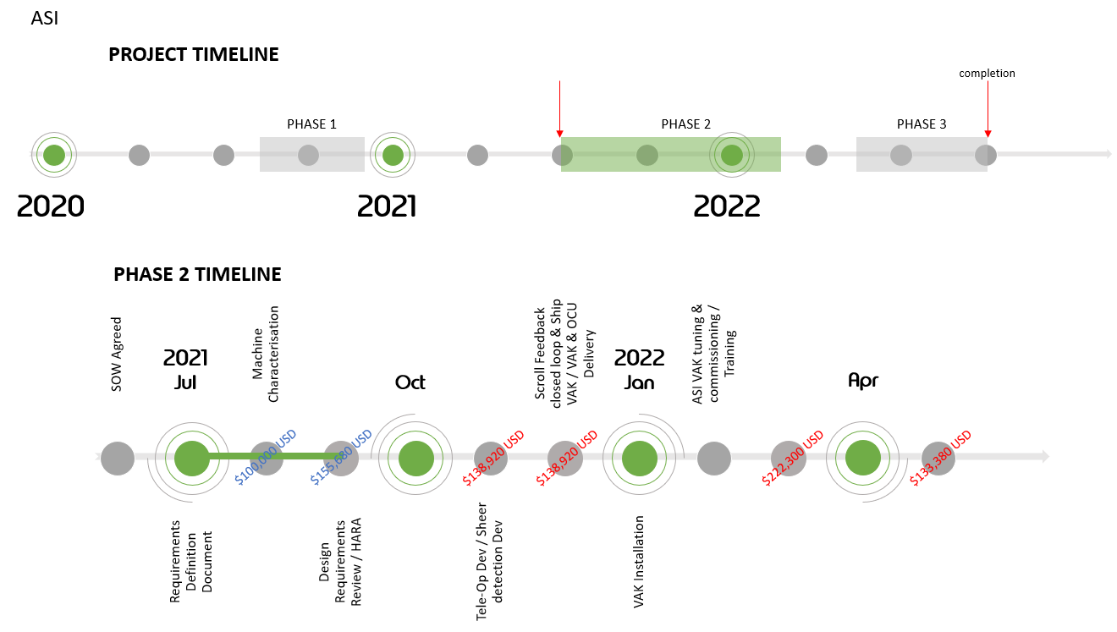

# Operations – August 2021

* Jamalco has reduced shift and AMC hours due to COVID-19 curfew, very heavy rainfall. A fire in the refinery powerhouse cut power to the RSA amenities further reducing onsite hours (no water, A/C etc). This is a severe event for the refinery and although there has been no official advice from the customer, we are expecting a significant contractual impact.
* Worsley recorded reduced AMC hours due to extensive maintenance requirements for their own MudMasters®. Phibion MudMasters® performed above contracted levels.
* Mt Weld recorded reduced AMC hours due to exceptional performance to date.
* Andoom had MM18 down for maintenance and a scroll changeout.
* MMX returned from Ravensthorpe and is awaiting refurbishment.

## Machine Maintenance/Breakdown

12 machines in operation during August across all our operations.

8 machines booked for service:

* 6 completed
* 2 rescheduled

Breakdowns:

* MMX - Fire suppression failure due to low system pressure, leaking hose found and replaced. 20 hours lost
* MMX – 12-volt system failure, repaired. 27 hours lost
* MM13 - broken belts. 8 hours lost
* MM13 - scrolls weld failure. 24 hours lost
* MM14 - fire suppression system failure occurred, risk managed and put back in service, awaiting spares to restore system. 20 hours lost
* MM14 - air conditioner failure. 30 hours lost
* MM18 - belly pan fastening system temporary repaired. 71 hours lost
* A6 – South32 – Worsley machine scrolls damaged, machine taken off site for major repairs. Time lost 99 hours

## Pending MudMaster® Deployments

* MM25 – MRN Trombetas (Brazil) Arrived Belem, awaiting clearance
* MM27 – ETA Port Antonio (Chile) 2nd September 2021
* MM28 – Complete and scheduled for departure 31st October 2021
  + AMSA Mauro (Chile) – Freight arrangements in preparation
* MM29 – Under construction and scheduled for departure 31st October 2021
  + AMSA Mauro (Chile) – Freight arrangements in preparation

# People

A Set Plan procedure was rolled out in July to assign KPI’s for all employees. Nearly all employees had their set plans finalised by the end of August.

The new starter process has been rolled out with three new Starters in the Phibion Head Office for August and 1x new employee in Chile. This continues to be refined into September.

With large expansion imminent the focus has been on establishing a Country roll out plan to identify the structure needed when establishing a presence in a new Country. Position descriptions and position requirements are being standardized to cover all sites.

A Country Manager has been assigned for Chile with the contract drafted and is set to be finalised early September.

The following table is a list of all Phibion employees.

**Australia**











**Jamaica**



**Brazil**



**Chile**



## 

## Turnover

Dismissal

There have been no dismissals for the month of August.

Role change

Both Tim Varcoe and Dianne Alexander left Brazil in August to start their travel to Chile to start operations with Anglo American.

## New Appointments and Vacancies

**New Appointments**



**Vacancies**



**Summary**

The HR structure, processes and procedures continue to be refined to fit in with expansion.







# Strategic Plan - Actions